In 1807 Thomas Burfield founded his rope company in Hailsham on the site we now occupy.
Thorndale history
In 1830 George Green, an employee of Burfield's, left to set up a rival factory across town called Green Brothers, making similar products but servicing mainly local industry.
Later that century in 1881, George Hawkins and Alfred Tipson founded Hawkins and Tipson, manufacturing out of the Globe Rope Works in Millwall on the Isle of Dogs, London. Hawkins and Tipson went from strength to strength and so in 1941 they bought Green Brothers in Hailsham and 12 years later in 1953 they also bought Green Brothers main competitor, Burfield & Sons here, where we are now.
By early 1950's the "new" synthetic fibres of Nylon (polyamide) and Terylene (polyester) were becoming more widely used in industry and Hawkins and Tipson were among the first to realise their potential in rope making.

In 1957 Hawkins and Tipson started manufacturing and selling synthetic fibre ropes, made in Hailsham, to the yachting industry under the "Marlow" brand. These new nylon and polyester ropes were ideal for the demands of the re-emerging yachting industry which was just recovering after World War II. The success of the Marlow brand led to the founding of Marlow Ropes Ltd in 1961, as part of the ever-expanding Hawkins and Tipson empire, with the express purpose of manufacturing synthetic fibre ropes for the yachting market.
During the 1960's Marlow Ropes very soon become internationally known in the yachting industry and leaders in the field.
The 1970's, saw Marlow Ropes (now the synthetic fibre arm of Hawkins and Tipson) moving from strength to strength, further asserting its dominance in the yachting industry. They soon became the dominant company within the group and by 1983 Hawkins and Tipson (now under new ownership) was restructured, becoming known as H&T Marlow and subsequently simply Marlow Ropes Ltd. It was around this time that the rope business moved out of Burfield Park to a new factory running alongside the Burfield Estate. This has since been knocked down as the rope company restructured once more and split up.
The 1980s:-
The Birth of Thorndale Furnishers
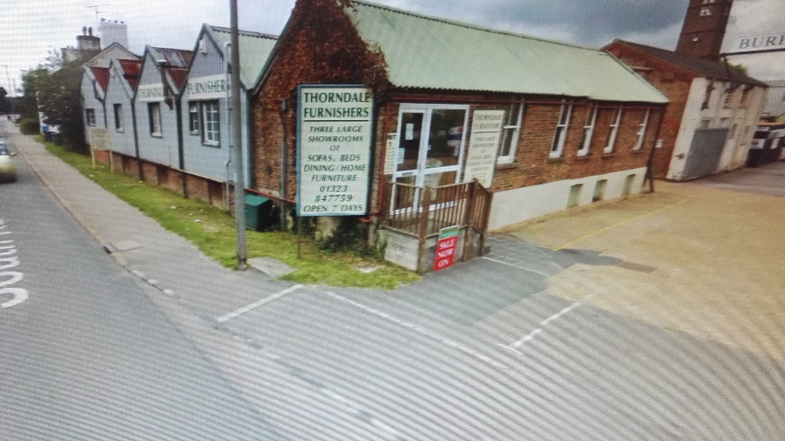
Due to illness Malcolm Baker gave up farming and began to sell secondhand cars and then three piece suites from a barn at their farm. In 1985 Malcolm and Jennifer Baker bought the first unit, Unit 1 of Burfield Park and brought secondhand sofas and chairs across on the back of a tractor and trailer. The unit had bare boards on the floor, very little lighting and the basement was dark and dank.
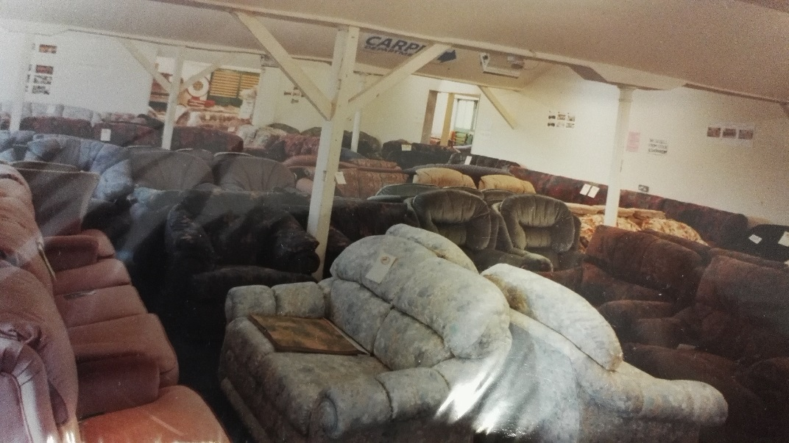
Within a short period, Malcolm and Jenny had taken on unit 2 and 3 that were all part of the same block and knocked out walls to expand their business with carpet on the floor and brand new suites. They did all the office work and the deliveries in their spare time between themselves.
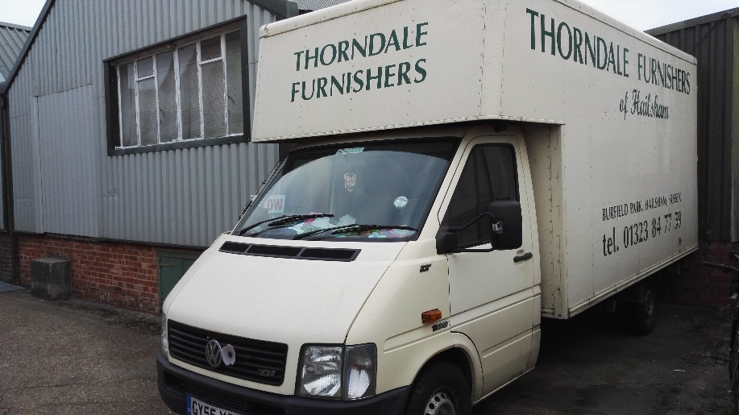
It was not long before they took on a salesman, Brian. They then began to display more models from new manufacturers and expanded their stock. They bought a van for deliveries using the help of their friends and family. They also employed a secretary, Anne.
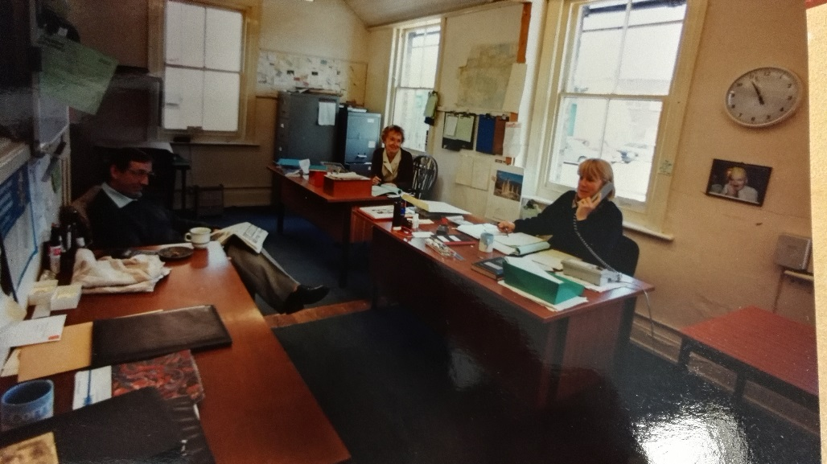
A further extension to the business was the purchase of unit 21, a large unit behind their roadside unit. At this point they went into a partnership with another gentleman adding beds and bedroom furniture to their display. Unfortunately, this did not pan out well and their partner never met expectations. That said, Malcolm and Jenny worked through this difficult time being left with huge debt with the cost of this added stock. It was stressful, but of course they survived.
In 1991 A furniture retailer in Heathfield closed down and Malcolm and Jenny phoned them looking for a permanent delivery driver. Clive joined them in this year becoming part of the team. It was a step backward from the position he had previously earned after 13 years in the trade, so his knowledge of furniture retail was to become more beneficial to the company.
In the 90’s the delivery van was stored at their farm some ten miles away and all the incoming orders to the shop were transported back there every day. On one occasion a whole van loaded with leather sofas and chairs was stolen. This was another big setback for the company and of course the customers who were waiting for them.
Today, of course, everything is stored in secured warehousing at the shop premises on wheeled racking.
Also in the 90’s the office work increased and so Tottie, Malcolm and Jenny’s youngest daughter was employed to help with day to day organising. Business was booming.
In 1994 Salesman Brian retired and his position was offered to Clive. Over time Clive took more responsibilities from Malcolm doing the pricing, ticketing and arranging displays as well as warehousing, decorating and buying.
A couple years later, still going from strength to strength it was time to relinquish temporary help on the delivery van and so Paul, from a closing Hailsham furniture retailer, was employed for the deliveries. Paul is still with us today.
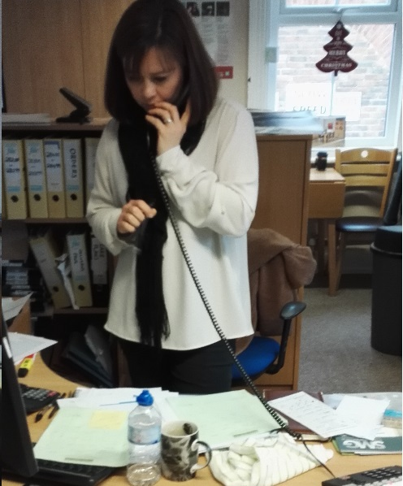
Over the coming years there have been a number of changes throughout the units: Walls were removed, others painted and carpets were renewed; Lamps and dining furniture were introduced and Sharon came aboard to help in the office after Anne retired. A number of other units on the Burfield Estate were purchased for warehousing and further showrooms for beds and bedroom, cane furniture and swivel recliners and chairs.
Since early 2000s Malcolm had taken a back seat from furniture and took on a pub near to where they live. The backbone of the furniture company was then Jenny’s domain assisted by Clive, Tottie, Sharon and Paul.
In 2010 Paul decided to work for himself so Thorndale Furnishers sold him the delivery van and he also bought his own new van for private work. Paul still delivers for us today.
In 2011 Tottie left the business and moved to France. Sharon then took a more important role in the office and Clive became Manager as Jenny began to ease back and spend more deserved time at home to do the things she enjoyed like breaks away on walking trips.
Thorndale took on a Salesman and over time a Warehouse operative and part time helpers.
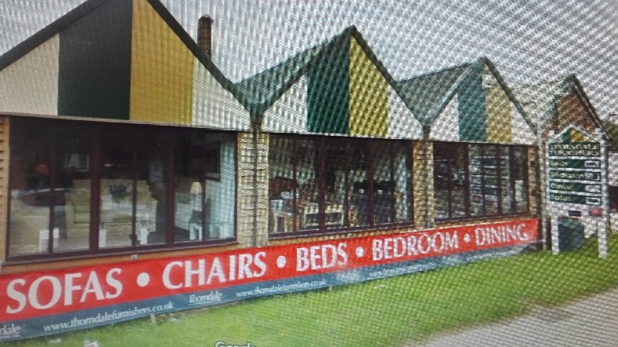
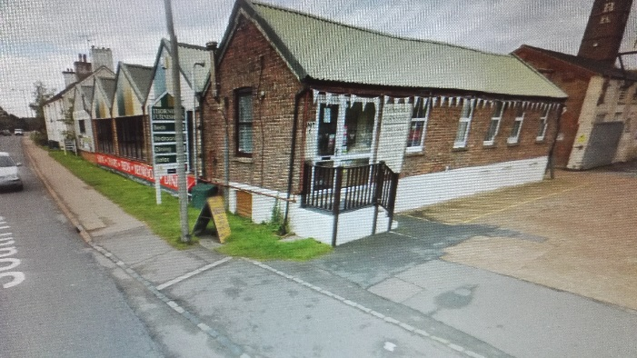
January 2015 Jenny had been diagnosed with cancer and struggled through that year with treatment and operations to no avail. She managed to see Christmas that year followed by the completion of roadside windows to their first showroom. Sadly, Jenny lost her battle in January 2016. She was and always will be missed by all for all the things she did for everyone, especially Malcolm who lost not only his wife but lifetime soul mate.
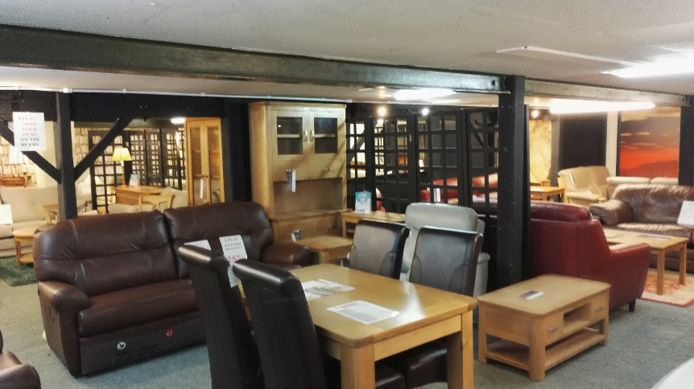
Following 2016 Malcolm has kept the business running placing his trust in his staff to uphold Jenny’s tradition and manor of business. Managed by Clive with staff Sharon, Isaac, Tim and other part time sales staff the business continues to grow with the changing times. Most of the company’s business has always stemmed from word of mouth, something Clive maintains is the best form of advertising when you earn the respect of your customer by being understanding and honest, having knowledge of your products and giving fantastic customary service. Thorndale Furnishers has a very extensive customer base stemming back over the years and so it is always nice when we welcome returning customers or recommended friends.
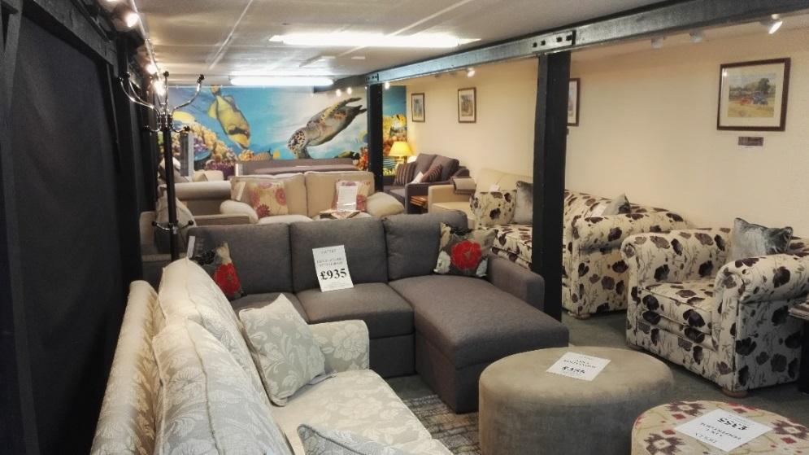
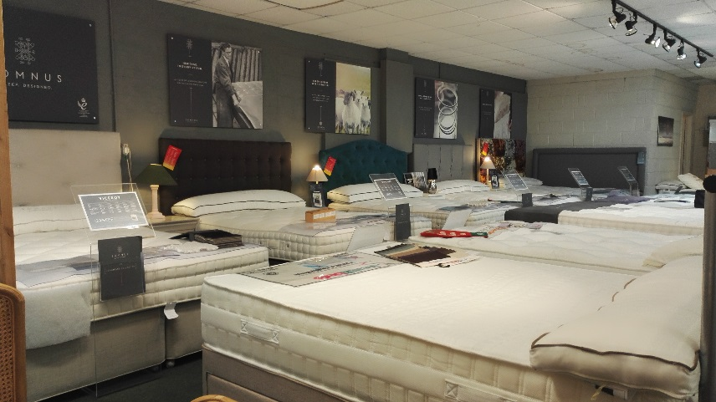
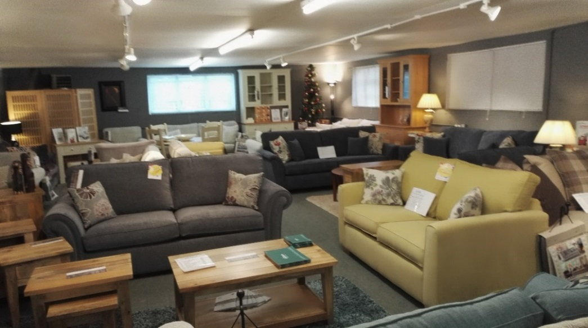
The extensive showrooms have always been a bonus to cater for the requirements of differing age groups, different qualities, different styles in sofas, chairs, dining, beds and bedroom. The wow factor can hit so many when there is a vast choice and can be a major point of conversation. Of course, styles change all the time and so as we move through the years we are still constantly decorating and adjusting our room sets. We deal with nearly 70 manufacturers to offer an array of choice. Our bed range stretches from lower budget open coil sprung mattresses to the flagship range of beds from Harrison Spinks “Somus” pocket sprung. Sofas and chairs are spread throughout from manufacturers around the country and the world. Our dining ranges display Oak, Teak, Mahogany, Acacia, and mango. There is certainly choice for everyone.
Once again sadly in 2021 we lost our director Malcolm to illness and so the business has passed down to Louise, the eldest Daughter.
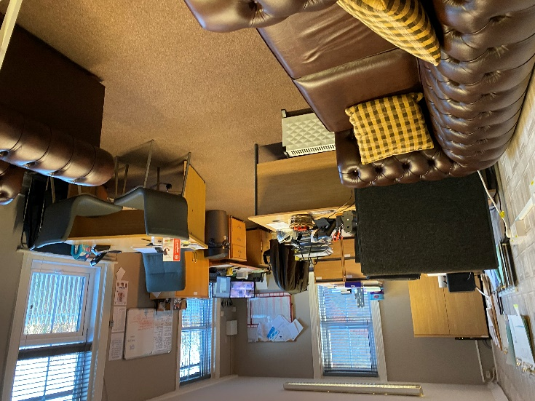
Now, with her fresh input and her view of how she would like to continue the shop as her parents’ legacy she would like to WELCOME YOU TO:-
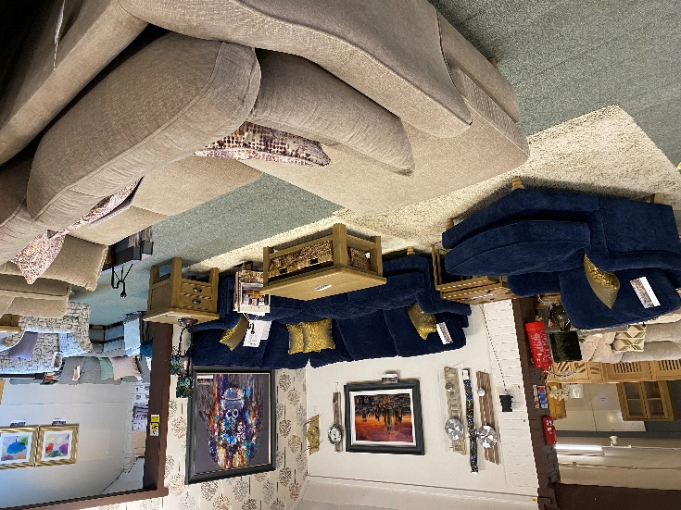
THE NEW THORNDALE FURNISHERS

